

# CS19611 - MOBILE APPLICATION DEVELOPMENT PROJECT REPORT

THE NOTES APP

*Submitted by*

# KALAISELVI S 220701116

*in partial fulfilment for the course* *for the degree of*

# BACHELOR OF ENGINEERING

**In**

# COMPUTER SCIENCE AND ENGINEERING

RAJALAKSHMI ENGINEERING COLLEGE RAJALAKSHMI NAGAR

THANDALAM CHENNAI-602 105

MAY 2025

# RAJALAKSHMI ENGINEERING COLLEGE CHENNAI – 602105

**BONAFIDE CERTIFICATE**

This project report titled **"THE NOTES APP"** is the bonafide work of **KALAISELVI S (220701116)**, who carried out the work under my supervision. Certified further that to the best of my knowledge, the work reported herein does not form part of any other thesis or dissertation based on which a degree or award was conferred earlier.

# SIGNATURE SIGNATURE

## DR.P KUMAR Dr. V. KHARTHIK

**Head of the Department Assistant Professor**

Computer Science and Engineering Computer Science and Engineering Rajalakshmi Engineering College Rajalakshmi Engineering College

Chennai – 602105 Chennai – 602105

Submitted to Project and Viva Voce Examination for the subject

CS19611 – Mobile Application Development Laboratory held on .

Internal Examiner External Examiner

# ACKNOWLEDGEMENT

Initially we thank the Almighty for being with us through every walk of our life and showering his blessings through the endeavor to put forth this report. Our sincere thanks to our Chairman **Mr. S. Meganathan, B.E, F.I.E.,** our Vice Chairman **Mr. Abhay Shankar Meganathan,B.E.,M.S.,** and our respected Chairperson **Dr. (Mrs.) Thangam Meganathan, Ph.D.,** for providing us with the requisite infrastructure and sincere endeavouring in educating us in their premier institution.

Our sincere thanks to **Dr. S. N. Murugesan, M.E., Ph.D.,** our beloved Principal for his kind support and facilities provided to complete our work in time. We express our sincere thanks to **DR.P KUMAR ,** Head of the Department of Computer Science and Design for his guidance and encouragement throughout the project work. We convey our sincere thanks to our internal guide and Project Coordinator, **Dr. V. KHARTHIK,** Assistant Professor, Rajalakshmi Engineering College for his valuable guidance throughout the course of the project.

KALAISELVI S (220701116)

**TABLE OF CONTENT**

|  |  |  |
| --- | --- | --- |
| **CHAPTER No.** | **TITLE** | **PAGE No.** |
|  | Abstract | 5 |
|  | Introduction | 6 |
|  | Literature Survey | 7 |
|  | Proposed System | 8 |
|  | Module Description | 10 |
|  | Implementation and Results | 12 |
|  | Conclusion and Future Enhancements | 14 |
|  | References | 14 |

**CHAPTER 1**

**ABSTRACT**

Notes App is a simple yet effective mobile application designed to help users organize their thoughts, tasks, and important information with ease. Developed primarily for Android devices, the application provides a clean and intuitive interface where users can effortlessly create, edit, and manage their personal notes. Each note includes a title and description, allowing users to capture ideas in a structured manner.

The application emphasizes a user-friendly experience with smooth navigation, minimalistic design, and real-time updates to the notes list. Following modern UI/UX principles, the app ensures that users of all ages can quickly add and manage notes without any complexity. Notes App is lightweight and optimized for high performance, ensuring seamless usage across a wide range of Android devices.

From a technical perspective, the project demonstrates essential Android development skills, including local data storage with Room database, dependency management with Koin, asynchronous operations with Kotlin Coroutines, and lifecycle-aware components using ViewModel and LiveData. Future enhancements could include features like search functionality, note categorization, reminders, and cloud backup for data synchronization, making Notes App a scalable and valuable productivity tool.

**CHAPTER 2**

**INTRODUCTION**

**2.1 GENERAL**

Notes App is a simple mobile application developed using Android Studio and Kotlin to help users create, edit, and manage personal notes. With a clean interface, users can easily organize their tasks, ideas, and reminders by adding titles and descriptions. The app focuses on simplicity and efficiency for everyday note-taking.

**2.2 OBJECTIVE**

● Develop an easy-to-use app for creating, editing, and managing notes.  
 ● Provide a clear structure with titles and descriptions.  
 ● Ensure smooth navigation and real-time note updates.  
 ● Use modern Android components for better performance.

**2.3 EXISTING SYSTEM**

Most existing note apps are either too complex with extra features or too basic with limited functionality. Many lack structured storage, smooth navigation, and a clean user interface, making simple note-taking harder than necessary.

**CHAPTER 3**

Several mobile applications currently exist for note-taking and personal

organization, such as "**Google Keep," "Microsoft OneNote," and**

**"Evernote."** These apps provide features like creating and organizing

notes, reminders, and syncing across devices. However, many existing

systems often lack:

● A clean and minimal UI focused on basic note-taking.

● Simple and quick note creation without extra steps.

● Lightweight performance suitable for low-end devices.

● Offline functionality for users without constant internet access.

Research on productivity and note-taking apps shows that users prefer

applications with minimal distractions, easy navigation, and quick access

to notes. However, many apps are bloated with advanced features, ads,

account sign-ups, and cloud syncing requirements, making them

unnecessarily complex for users who need a basic, offline-friendly note

making tool.

**CHAPTER 4**

# PROPOSED SYSTEM

**4.1 SYSTEM OVERVIEW**

**Notes App** is a simple note-taking application that lets users create, edit, and delete notes with ease. It focuses on a clean design, smooth navigation, and offline functionality for quick and efficient note management.

**4.2 SYSTEM ARCHITECTURE**

● User opens the app  
● Views all saved notes  
● Adds, edits, or deletes notes (title + description)  
● Changes are updated instantly  
● Data is stored locally using Room Database

● Navigation between screens using Navigation Component  
● Data handled efficiently with ViewModel and LiveData for smooth updates

● Dependency Injection managed using Koin for clean architecture  
● Asynchronous operations handled using Kotlin Coroutines for smooth performance

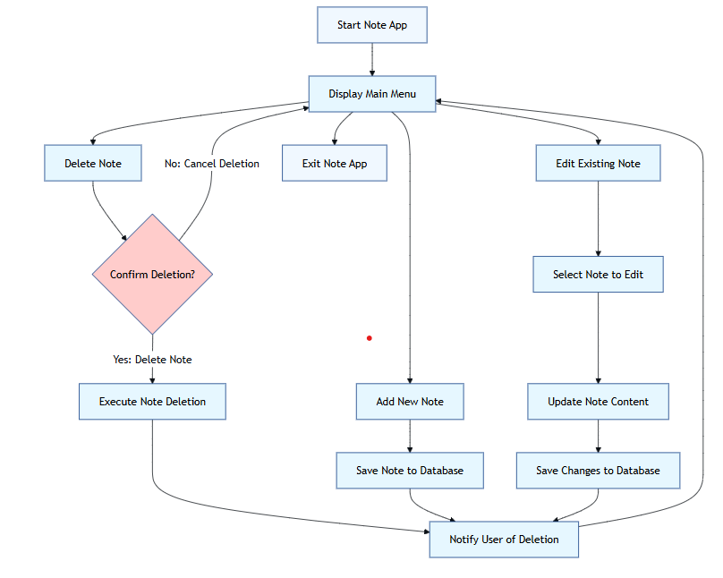

(Fig 3.1 System Architecture)

**CHAPTER 5**

# MODULE DESCRIPTION

**5.1 MODULES**

**● Note Management Module:**Allows users to create, edit, and delete notes with a title and description, ensuring easy management of personal information.

**● Local Storage Module:**Uses Room Database for storing notes locally, ensuring offline access and fast retrieval of saved notes.

**● Data Handling Module:**Utilizes ViewModel and LiveData for lifecycle-aware data management and real-time updates, ensuring smooth and consistent data flow.

**● UI/UX Module:**Implements a simple and clean Material Design layout, providing an intuitive and responsive user experience with smooth transitions between screens.

**5.2 ACTIVITY DIAGRAM**

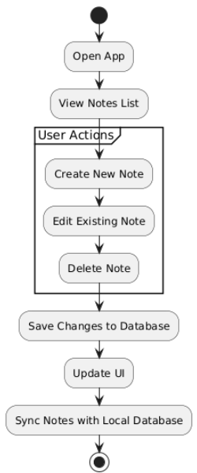

(Fig 4.1 Activity Diagram)

**CHAPTER 6**

**IMPLEMENTATION AND RESULTS**

**6.1 TOOLS USED**

* Android Studio
* Java
* XML for UI
* SQLite (for storing notes)
  1. **OUTPUT SCREENSHOTS**

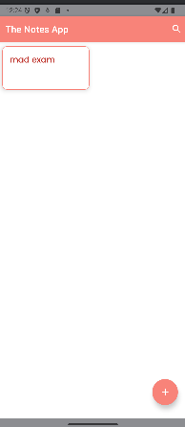 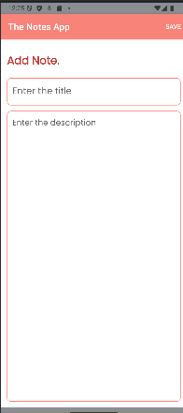

(Fig 6.1 App Home Page) (Fig 6.2 Add Notes)

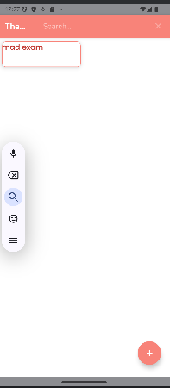 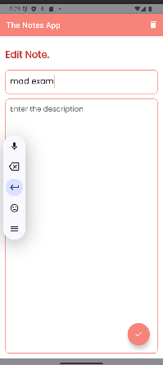

(Fig 6.3 Search the Notes Added) (Fig 6.4 Delete or Edit the Notes)

**CHAPTER 7**

**CONCLUSION AND FUTURE ENHANCEMENT**

**6.1 CONCLUSION**

The Notes App provides a simple, intuitive solution for users to create, edit, and manage their personal notes. With features like local storage using Room Database, real-time updates with ViewModel and LiveData, and seamless navigation, the app offers a smooth and effective user experience for organizing and managing notes.

**6.2 FUTURE ENHANCEMENT**

● Implement cloud synchronization for cross-device access to notes.  
 ● Add a search functionality for quicker note retrieval.  
 ● Include reminders or notifications for important notes.  
 ● Add categories or tags for better note organization.

**REFERENCES**

# Android Developer Documentation

# Material Design Guidelines for Mobile Apps (2024)

# Room Database Documentation for Android

1. Android Navigation Component Documentation